ICSMSU 5th General Meeting 2022-23

04/12/2022: 19:00 – 21:00

Reynolds Building

PRESENT | Christian Oldfield, Lilia Evans, Nia Davies, Nick Lawson, Sean Li, Rayyan Islam, Zeynah Alhadad, Raunak Chugani, Monica Jin Yang, Matthew Qurku, Pedro Chen, Nick Soon, Olivia Wing, Asra Shah, Hafsa Jalisi, Maya Alazzawi, Angellica Marta, Yasmin Baker, Aoife Madden, Hamza Ikhlaq, Haider Nazerali, Eve Butler

APOLOGIES
Action points of the last meeting | Officer Reports
Matters Arising | Dates for your diary
Next Meeting | Action Points/Deadlines

Agenda
- Action Points From Last Meeting
- Common Room Ideas
- Welfare Integration and Utilisation
- Gladd Charter
- Immersion Week
- Phoenix Plushies & Merch Restock
- Light Opera’s Legally Blonde
- Officer Reports
- Any Other Business
- Next Meeting and Dates for your Diary

Discussion Points

ACTION POINTS OF LAST MEETING
Action Point 1 | Action Point – Complete/In Progress/Not Complete
Nick to edit the V&A awards criteria and send to SU to review | Complete
Nia to send out feedback form to Fresher Buddies | In Progress
Nia to get feedback from Club Captains about how first sports night should be managed  Eg. Should timings be changed so reynolds is open from 6 to allow rolling entry? | In Progress
Chris to speak to UH presidents about how they manage queuing at events | In progress – Chris has requested to add it to the agenda for the next UH meeting, however these do not happen regularly
Aoife to make a Freshers’ Fortnight Debrief Document | Complete  ICSMSU -> Ents -> 2022-23 -> Freshers’ Fortnight Debrief

MATTERS ARISING
Common room ideas | Common rooms to be redesigned:  - SAF common room  - Charing cross basement common room  SAF – to be aware that this is a space for medics and BMB  - Bean bags (red, yellow, blue)  It should be considered that this is a space that anyone can walk into, therefore it should be considered whether things can be stolen| vandalised  Think about things being moved out of the rooms, lost etc  - Fake plants (possibly with fairy lights around them)  - Microwaves (these are functional, but could be updated if there is funding)  - New kettle  - Leather to reduce spillage risks  Charing Cross – this is a medic space  - New microwave  - New kettle  - Leather to reduce spillage risks  From Mary’s  - Signs for the walls  - Sofas  Liaising with other UH universities who have recently updated common room spaces to compare design ideas and feasibility  Society photos and notice boards in each room to be updated
Welfare integration and utilisation | How streams should be using welfare:  - Welfare issues beyond your stream remit should be passed onto welfare  - If there are welfare issues that cross over with your stream, work with the welfare team to resolve the issue together rather than bypassing them  - AOEY and AOCY should be working with welfare stream for the SSLGs to collect form responses – this will strengthen arguments put towards faculty  - If you are not sure whether welfare should be involved, reach out to the welfare stream for direction
Gladd charter | A charter against ‘Conversion Therapy’ in the UK. The majority of the medical schools in the country have signed the charter and all London medical schools (bar ICSM) have signed.  Our aim as an SU is to get the faculty to sign the charter. The school of medicine (ICSM) is unable to sign without the approval of Imperial College.  Provisionally, SU have voted for the faculty to sign the charter.  https://res.cloudinary.com/gladd/image/upload/v1668801240/documents/UK_Medical_School_Charter_on_So-called_LGBTQ_conversiontherapy_5_ge6fny.pdf  https://gladd.co.uk/activism-conversion-therapy-charter/
Immersion week | 22 second year students from LKC medicine come to the UK for one week to experience life at Imperial.  Webinar to be run by the SU before they arrive, to give a chance to ask questions in break-out rooms:  - A Wednesday 12:30pm (date tbc)  SU to welcome and mingle with them  Events that SU are expected to attend:  - Monday 27th February --> Scavenger hunt (similar to the BSc cohort connect event), this will be with faculty present  - Wednesday 1st March --> Accessible event that the SU will run  Ideas for the Wednesday event:  - Sky garden  - Musical  - Mini golf  - Live music – jazz bar/ café (pizza express Soho)  - Arcade/ flight club  - Gravity (Wandsworth)

OTHER BUSINESS
Phoenix plushies & merch restock | 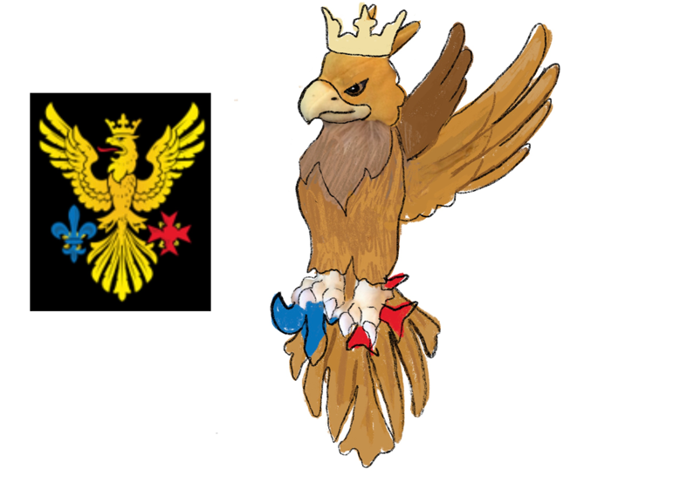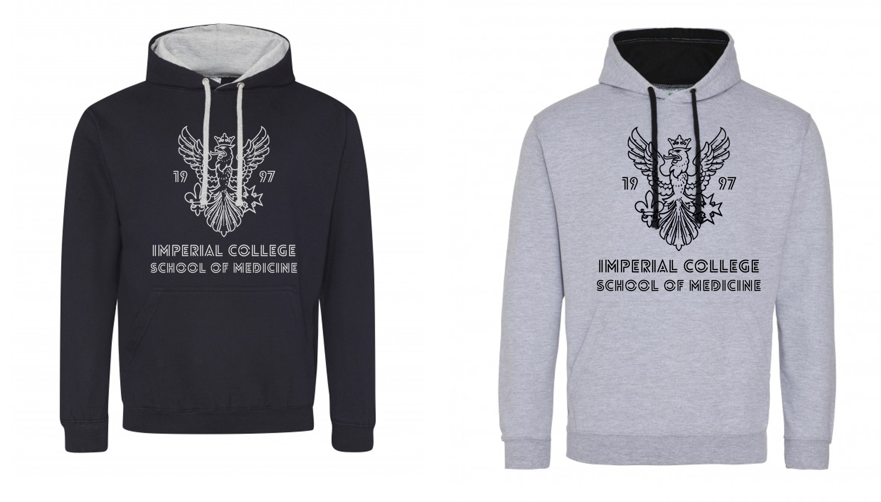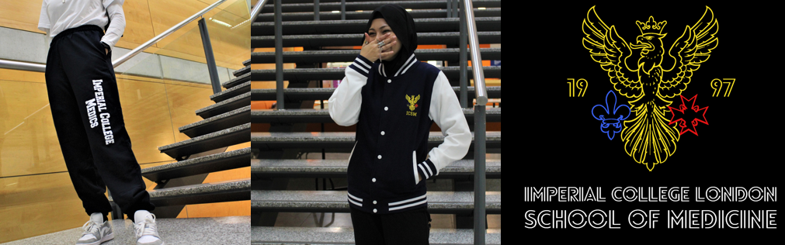  Imperial College Union best-selling item is a teddy bear/ soft toy with Imperial branding  Phoenix plushies  - To mimic the phoenix mascot  - Minimum order of 500  - ICSM t-shirt  - Consider the environment implications and whether creating this new brand of stash is viable  - Consider as an STFYD gift, the remaining 200 phoenixes can be sold on the shop  Hoodies  - New logo is preferred
Sports team photos | What is the best way to do these photos  - Photographer is booked for a certain number of hours  - Clubs are given time slots  - Orders to be made to CCs and communicated to the SU who will print photo orders  When are the best dates  - Freshers have finished exams (they may be less likely to attend, whereas older members might be more committed)  - End of March – clubs and socs stream would need support with this  Clubs and socs should look into working with ICU on this  Clubs to pay for photos (Cricket photo ~£15 as a price point comparison)
Imperial Huawei deal | Welfare have been working with feo to successfully block the advertisement of the deal between Imperial and Huawei
SEF applications | Deadline for stream applications is next week
NEXT MEETING | Sunday 08.01.2022
DATES FOR DIARIES | Volunteering and Academics Award Evening: Thursday 8th December  Snowball date: Monday 12th December  Arts Dinner: 19th January  Immersion Week:  Monday 27th February, evening – Welcome Event  Wednesday 1st March, evening – ICSMU Social event  Friday 3rd March, late afternoon – Farewell

Officer Reports

EXECUTIVE
President | - I have finally had a full free weekend can’t believe it  - We had the Transform MedEd conference where I got to spend a few days with the LKC MedSoc president & VP Education & spoke in closing remarks about students’ experience of MedEd  - I have been doing many visits to hospitals for data collection for quality improvement & two more SSLGs (kept to time!!)  - Worked with Aoife to update lists of contacts in Mailchimp to most up to date addresses  - Union Council meetings, particularly looking at the showing / promoting of the World Cup at Union venues  - Worked with ents team & ICU venues team to get world cup shown at Reynolds  - Increasing work on EDI projects, following up on BMA charter work  - Accomplishment project survey released to 2nd & 3rd years  - Been involved in a few other welfare / clubs & socs issues
Deputy president | - Done the usual certificates that people have asked for  - Involved on the constituent union forum board with Chris  - Involved with elective awards for final years – read through 121 applications!  - Debrief of halfway dinner with Chris and Hafsa  - Working on getting UH board updated in Reynolds Bar  - Communicating with ICU to get tankards at Reynolds updated  - Finished firms for this calendar year!
EXECUTIVE TREASURER | - Got £350 (incl. VAT) from Wesleyan, working with Aoife to advertise it  - Debrief with HWD, Chris, and Redro – need to finalise some refunds for non-alcohol tickets  - Liaising with ICSM Alumni Association on behalf of BMB and STYFD teams, and to organise Phoenix Fund meeting  - Working with Maya for Arts Dinner Budget  - Did my Exec takeover!  - Rehearsing lots for my musical, come watch me I am a lead  - Also revising for SJT if you can even do that
SECRETARY AND COMMUNCIATIONS | - Ran and coordinated our exec Instagram takeovers  - Released the weekly newsletter  - Released the internal newsletter  - Formatted some of the emails Chris sent out to different year groups  - Updated the emails on Mail Chimp with Chris  - Chased up action points from our last meeting  - Met with Dorrit to discuss how faculty of medicine staff can better support us with comms
SITES AND SERVICES | - Held second merch stall of the year, sold £1,200 worth of merch  - Took measurements of the common rooms, in process of designing  - Put together pricing suggestions  - Attempted to clear out locker room. To continue over holidays.
BMB Society PRESIDENT | - Worked on sponsorship letter with BMBSoc treasurer  - Sorted out BMB Christmas Dinner  - Presented in EDI forum regarding EDI issues in BMB  - Discussed Yearbook w Academic Officer - Thank you Monica xx  - QuadBio Clubbing Night at Embargo

ACADEMICS
ACADEMIC CHAIR | - SSLG month!  - Went to clin years, early years and BSc SSLGs – all variable in length, but massive improvements over previous years! V lovely  - Helped out a bit with BSc to prep reps a bit (will likely do the same for BMB upcoming next week)  - Have done a centralised CPA OSCE scheme with the big 3 academic socs (went later than I would’ve liked bc of personal stuff but plenty to work on for next year should we want to continue it)  - Started mocks planning with the rest of academics (and started booking out spaces, 7th floor already confirmed, CX to come this month)  - We have an arm in SU officer now for some reason??? May be doing some more wrt purchasing equipment with SEF etc  - Working with sports and arts socs on their mocks (variably)  - Some variety of meetings? Union Council, some with faculty, etc etc it’s all kind of a blur, may be some more as well  - Pretty chill month notwithstanding
ACADEMIC OFFICER For Early YEARS | - Changed structure of rep SSLG feedback Report to make it more concise  - Organised pre-sslg module meetings which were successful, allowing reps to discuss feedback in depth and create action points to bring to the SSLG  - Had successful first Y1 & Y2 SSLG which didn’t majorly overrun and was very productive!! (Only overran by 15 mins compared to 1hr 30 mins last year!)  - Set up QuestionBank fully so societies are working now on uploading their academic questions  - Started organising CPA Mocks and had meeting with MM, MedEd, SurgSoc & AMSA = have a solid timeline plan so everyone is briefed on what is needed and when  - Helped with accomplishment survey to Y1 & Y2’s  - Worked with Digital team to improve timetable information, especially for Y3 (as found it hard to navigate and find out where sessions are within insendi)  - Had meeting with Dept of Primary Care to help improve prescribing teaching within younger years curriculum and helped set up Student Shaper project  - Attended Taught Academic Representative forum led by Deputy President for Education
ACADEMIC OFFICER For Clinical YEARS | - Performed handover for Year 3 academic reps and assisted them in preparation for the term 1 SSLG  - Read through reports and assisted in its analysis  - Organised Pre-SSLG meetings for Year 3, 5 and 6. They went successfully and allowed reps to discuss more minor concerns with their respective heads of year that otherwise wouldn’t be addressed in the SSLG  - Had a successful Term 1 SSLG – the academic reps were amazing!  - Updated note bank with more notes  - In the process of planning mocks
ACADEMIC OFFICER For BSc YEAR | - Met up with academic reps from 15 pathways and prepared them for their first SSLG  - Read through reports and presented main findings during SSLG  - Completed first SSLG of the year  - Liaising with Lilia and social reps to organise sufficient socials for BSc students  - Setting up 1-to-1 meetings with academic reps to make sure they are finding the role fine  - Organising next Cohort Connect Event!
ACADEMIC OFFICER For BMB | - Helped prepare Student Feedback Reports, submitted all the reports from Student Representatives to FEO BMB 123, approved draft agenda for SSLG BMB 123 – all set for term 1 SSLGs!  - Attended Taught Academic Representative Forum lead by Deputy President for Education  - Wrote a Student Feedback Report surrounding the issues of Equality, Diversity and Inclusion (EDI) for the EDI Board for Undergraduate Science – thanks Angie for presenting the report to the board!  - Begun working towards creating Yearbooks for the Class of 2023 by talking to Hafsa, GradFinale and Angellica – thanks for the support, Angie!

WELFARE
WELFARE CHAIR | - Continued to support students and societies with welfare supporting and reporting pathways.  - Met with FEO to discuss Raising Concerns pathway/feedback.  - MASSIVE win for inclusion. Accessible toilets are to be signed for all genders to utilise.  - Comms Room C is reinstated as a multi-faith prayer room for students when not booked for teaching.
VICE CHAIR For Campaigns | - Liaised with campaigns team for November throughout to create posts  - Prepared December month post (still yet to go up)  - Made group chat with team for finance for brainstorming ideas for the next month
VICE CHAIR For  WEllbeing reps | - Met with all the well-being representatives (except Yr 5) remotely & delivered training on signposting & how to write surveys + reports for SSLGs.  - Arranged pre-SSLG meetings with well-being representatives to brief them on SSLG structure and discuss what points should be discussed more/less.  - Attended and supported all Well-being representatives in their SSLGs.  - Action points for Phase 1 (early years):  - Discuss the timetabling issue with Mary Morrel & James Moss + reiterate to staff the 10-minute break is mandatory (completed)  - Arranging meeting with Academic tutoring team to discuss how tutor meetings can be tailored to fit the needs of the cohort (in progress)  - Meet with PCH team to discuss Welfare access points on placement (in progress)  - Action points for BSc  - Meet with Senior Tutors & pathway leads to discuss Welfare talks at start of year & areas for improvement – meeting scheduled for January. (completed)  - Liaise with Academic team to arrange termly check-ups with the social representatives (in progress)  - Action points for Clinical Years  - Clarification on Student’s rights on placement specifically on night shifts – Amir Sam to reiterate to hospital sites. (completed)  - Discuss with FEO if we can put a document in place detailing student’s rights on placements so students know if and when it is appropriate to raise a concern. (in progress)  - Similarly, to Phase 1 – improving signposting & working with teaching coordinators to ensure there are Welfare access points on site. (in progress)  - Action point for all  - Meet with FEO Welfare to discuss any ideas on improving the current resources & additionally identify why students are not engaging with the resources we have. (in progress)  - In other news I am choreographing ICSM Light Opera’s Legally Blonde – pls come watch, Hafsa is a lead and she will cry if you are not there. Don’t make Hafsa cry.
Welfare officer for bmb | - Reviewed Student Representative Feedback Reports for the SSLG BMB 123  - Briefed Student Representatives of all years on their roles and how to make reports with Monica  - Wrote a Student Feedback Report surrounding the issues of Equality, Diversity and Inclusion (EDI) for the EDI Board for Undergraduate Science

MANAGEMENT GROUP
CLUBS AND SOCIETIES CHAIR | - Organised faculty and SU panel for voting on Volunteering and Academics awards  - Visited venue for Arts dinner (very exciting!)  - Promo of Volunteering and Academics Awards Evening  - Attended CSPB meeting  - Voted as part of NAC panel on new societies  - Finished Movember (mo is gone finally)
MANAGEMENT GROUP TREASURER | - SMHA and SMDT Grant applications all received and recommendations are sent to the Board for further approval (30+ applications)  - Sponsorship emails sent for the 3 Dinners  - Started and finished with second round of ADF application process (55 applications)  - The usual speedy eActivities grind
VICE CHAIR For  SPORT AND ARTS | - Arts Dinner venue liasing – after viewing we have decided on a venue!  - Arts dinner: Event budget, event proposal form and risk assessment  - Arts dinner: aiming to have a contract with the venue and deposit needs to be paid  - Attended CSPB meeting  - Instagram takeovers are still ongoing  - Helping out societies whenever they face any issues
VICE CHAIR For  VOLUNTEERING AND ACADEMICS | - Finalised organisation for volunteering and academics event  - Lots of promo for the event as well  - Voted on the new activities panel  - Helped out societies with some issues they were facing

ENTERTAINMENT
ENTERTAINMENTS CHAIR | - Hosted SU social (now running for Clubs and Socs chair)  - Organised showing of world cup games at Reynolds (thank you everyone who came)  - Organising post PFA event – prosecco and canapes  - Finished jury duty wooooo!
SOCIAL SECRETARY | - Promo and final prep for Snow Ball – coordinating with Bands/DJ and venue  - SU social! - made Chris and Aoife cry ie great success  - Joined ICU Exploration Board  - Coordinated Clubs and Socs for Snow Ball video – out on Monday
RAG Chair | - Started fashion show chair interviews!  - Started collections for a second hand clothing sale that we are planning on running in RAG week  - Opened submissions for circle line t shirt designs  - Working with hope for children to start the skydiving challenge  - Working with RAG committee to ensure RAG week preparations are going smoothly

Action Points and Deadlines
Action POINT | Person Responsible | Deadline
AOEY & AOCY to meet with Lilia to plan how to combine surveys for SSLGs | Lilia, Yas, Nick | Before 08.01.23
To make the welfare campaigns plans available for the SU | Eve | End of term
To communicate the Reynolds steps photo idea to club captains | Nick | End of term
Haider & Hafsa to communicate about stash money | Haider & Hafsa | In the new year
To communicate with Dylan (ICU) about the Reynolds steps photo | Nick | End of term
Chris to liaise with student for faculty EDI forum | Chris | 06.12.22
Pedro to check that there are updated tankards for each SU position | Pedro | This week
Meeting to discuss BSc social reps and society app | Rayyan, Raunak, Lilia, Nick | Before 08.01.23

