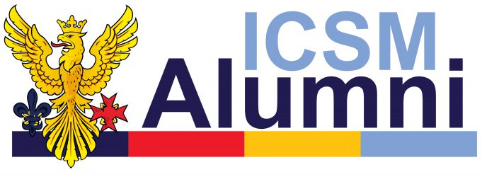
ICSM Alumni Association meeting 17/12/20

Members present

Muntaha Naeem- ICSMSU President
Pedro chen- ICSMSU Management Group Treasurer
Ben Russell- ICSM Student
Dan Faehndrich- ICSM Student
Anojan Arulnathan- ICSM Alumni Association Chair
Christian Oldfield- ICSMSU Clubs and Socs
Ken Wu- Ordinary Member
Zeba Azeem- Gazette Editor
Anil Chopra- Ordinary Member
Neeraj- Ordinary Member

- Financial report

- 250 current members
- September balance ~£15100
- ~£6200 held in our account, in ICTrust ~£80,000,
- SU money is being debited from ICTrust account
- grant money coming from our account
- 24 new sign ups in 2020- lower than expected. Covid likely to be a factor however low sign up needs addressing.
- Bob Phillips trying to get Westminster alumni to sign up in January
- They are likely to support a sports bursary

- SU Financial report

- ICSMSU President salary now fully funded by Faculty of Medicine
- Extra money from Alumni that would have been spent on salary to be reinvested into students events and reducing ticket costs
- This money is not to be spent on food and drink as it would not constitute a charitable purpose
- To be spent on essential costs such as ground hire
- Idea for final year collage sponsored by alumni- would increase visibility of the association. ACTION- DF to contact alumni association once estimate of costs have been ascertained
- DF suggested better advestisement of new things being funded to help with visibility of the Association. ACTION- RA to post for each new funded thing on social media
- STFYD may or may not go ahead this year
- Last year’s STFYD grant money to be redistributed however the current STFYD committee sees fit ACTION- RA to contact current STFYD committee
- Suggestion of subsidizing yearbook- organized by KaYan Cheung. ACTION- RA to contact yearbook chair
- Money that was to be spent on the sabb now to go to the SU to spend as it likes (with food and drink caveat)
- MN proposed below funding model outlining distribution of £10k and £3k for bursaries
- 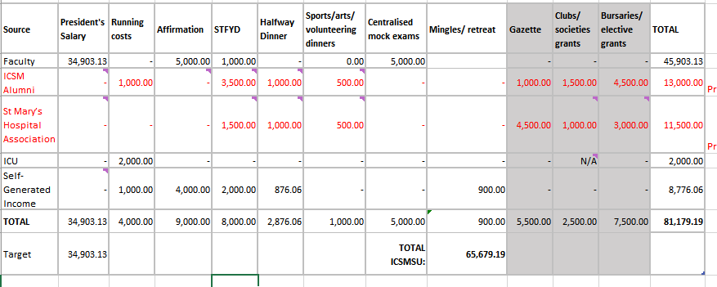
- BR says money breakdown needs to be reported to ICSM Alumni and advertised to students ACTION- ICSM Exec to produce annual report for AGM outlining how funds were allocated in comparison to above model. RA to email in advance to request this
- AA suggests continuing with £10k (+3 for student grants) however this could be increased by an extra £2k for running costs as freshers didn’t happen

- Clubs and Socs grants

- 1 application for £1500 for airway sim from PHEM. See appendix 1 for application
- Number of members 20. Could defer until next meeting. Current SGI £800
- Concern about if club folds what would happen to it.
- As only application we will allocate £500 and then pending further applications give the rest in next meeting. ACTION- ICSM management group to inform PHEM and allocate funds accordingly. ICSM management group to encourage applications in advance of next meeting

- Mike Schachter Memorial

- Mike Schachter former Honorary President sadly passed away recently
- DT proposes that the association purchases something honor his contribution to ICSM
- Suggestion of Mike Schachter Fund- for opera and music. Music already has a Music Alumni funded scholarship. ACTION KW to contact music to see if the Association could support this in any way. DT to contact Opera to see if they would consider setting up an Opera scholarship
- Suggestion of memorial bench at Gleinborn (£5000 so may have to be crowdfunded). KW suggested Holland park opera memorial as it is closer. Royal Opera house chair is also in London. ACTION: KW and DT to bring different options to next meeting
- Music and arts award like Sir Roger Bannister sports award in final year. Alumni association award could potentially be renamed.
- AA suggests it should be based on talent rather than contribution to not overlap with fellowship/ OSA. ACTION: MN and AA to formalize wording and gift

- Trustee election

- AJ stands down as chair and is re-elected. Votes for: 4, against:0, abstain:0
- New trustee to be elected
- RA elected as third trustee. Votes for: 4, against:0, abstain:0

- Membership

- Westminster alumni database being formulated by Bob Phillips. Keen to support O driscoll rugby scholarship- ~£500 a year. Westminster name is a sticking point that must be included
- Struggling to get sign ups for recent graduates.
- AA Suggests to set up stepped membership. With access to the mailing list as a non paying route to membership and optional donation to a ‘phoenix fund’.
- This would have the advantage of retaining contact with members as the become more likely to donate
- Would be more accessible for SMHA
- Would be helpful to have a database for centralized mock paces
- Constitution will need to be amended by exec. ACTION: AA to propose constitution changes
- AC suggests Phoenix Fund to be used in advertisement. As it distinguishes more from the College. This is to take place after constitution amendments have been sorted.

- AOB

- ZA presents Gazette report. Gazette next issue in January. Development on website and new podcast. ACTION- RA to circulate next Gazette issue after publication
- Wednesday 21st April final year photo date. 23rd of April could be doctor day. ACTION: MN to liaise with School of Medicine to get the Association an opportunity to address Class of 2021 in this time. RA to chase
- MN discusses move out of MDL labs in SAF building to RCS labs which are older
- Asks for the association to reshare ICSMSU survey pushing for transparency ACTION: RA to reshare
- AC advises to push the message that it is affecting the student experience. Undergraduates are important to the functioning of the college
- Changes to UKFPO scoring system which affects current students. Students were not consulted. ACTION- RA to reshare any further posts about this
- Reynolds Bar- not reopened this year. Will potentially open if Tier 1 in term 2. Guaranteed open term 3.

AA thanks all for attending. Meeting closes
Appendix 1
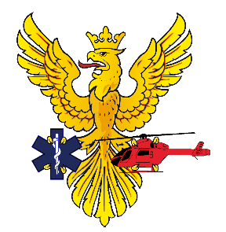 | Imperial Pre-Hospital Emergency  Medicine Society  Imperial College Union  Beit Quadrangle  Prince Consort Road  London SW7 2BB  icu.phem@imperial.ac.uk
Dear ICSMSU Alumni Association,
I write on behalf of the Pre-Hospital Emergency Medicine Society (ImperialPHEM) to express our interest in applying for a grant of £1,684 to allow us to purchase a Laerdel Airway Management Trainer to set up simulation training and moulages for medical students interested in critical and emergency care.
Laerdel Airway Management Trainers are the gold-standard training devices for teaching airway management, and are widely used within the NHS. Airway management is a critical skillset that is near-impossible to teach without simulation, because of the need to be familiar with the equipment and anatomy. By purchasing a trainer, we will be able to facilitate clinician-led teaching to allow students to become competent at recognising and managing a compromised airway in the emergency setting.
Due to the stress involved in critical care, we try to instil students with the ‘muscle memory’ and reflexes needed to remain calm and execute key skills when they are experiencing a reduction in bandwidth. Repeated teaching, practice and feedback from early in their medical careers will allow students to hone their skills, so that when faced with real patients they are highly competent, thus improving patient care.
Purchasing this will have both immediate and long-term benefits to the student population. ImperialPHEM has facilitated ambulance observer shifts for many years, where students could observe Pre-Hospital care and the skills involved under the guidance of paramedics. However, due to the impact of the pandemic, these shifts have been suspended indefinitely, and in-person training in skills labs is not possible due to social distancing. As such, we are planning to develop a novel approach with other Pre-Hospital societies across London to deliver online clinical skills drills and teaching. We are also interested in forming partnerships with other similar societies at Imperial, to benefit the largest number of students possible.
Once these restrictions are over, we plan to run biweekly clinical skills training sessions and moulages to teach and simulate the management of critically unwell patients – both medical and trauma – including airway management, trauma and ILS. Both the online and in-person teaching will be significantly higher-quality and more realistic with access to the trainer – delivering benefits to both the students and their future patients.
We endeavour to purchase the equipment from SP Services, a market-leading supplier of medical equipment, and from whom we have previously purchased equipment. We appreciate that the cost of the trainer is significant, however firmly believe that this is the single most valuable piece of equipment that we need, and have explored all other options. If the committee would like to support us but are unable to offer the full cost, any contribution would be extremely valued and we will investigate other sources of funding to complete the cost.
Thank you for taking the time to read and consider our application.
Kind regards,

Benjamin Watkins
President, Imperial Pre-Hospital Emergency Medicine
benjamin.watkins18@imperial.ac.uk / phem@ic.ac.uk

